PARISH REGISTRATION
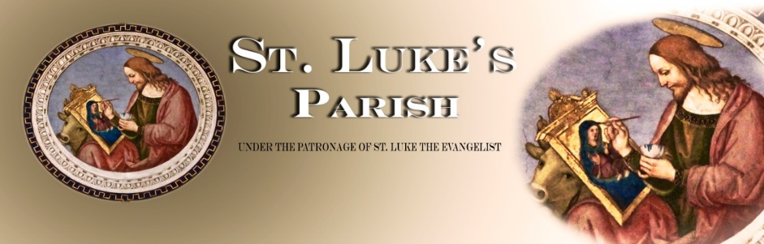
ONE REGISTRATION FORM PER FAMILY.
PLEASE FILL IN A SEPARATE FORM IF YOU ARE 18 AND ABOVE
(please use BLOCK letters)
NAME | F I R S T N A M E |  | L A S T N A M E
Home address
CONTACT PHONE NUMBER | HOME | MOBILE |  | WORK
PERSONAL/
PREFERRED EMAIL

NAME OF SPOUSE | F I R S T N A M E |  | L A S T N A M E
CONTACT PHONE NUMBER | HOME | MOBILE |  | WORK
PERSONAL/
PREFERRED EMAIL

Person(s) living with you
NAME |  |  |  | AGE

WHERE WOULD YOU LIKE TO HELP IN OUR PARISH COMMUNITY

Please tick the box indicating which Ministry or Activity you would like to assist in our Parish

 | Altar Server |  | Commentator
 | Collection |  | Music, choir member
 | Hospitality Team |  | Minister of the Word
 | Children’s Liturgy |  | Special Minister of Holy Communion
 | Joining a committee |  | Volunteer army (for general activities)
 | RCIA Team |  | Children’s Sacramental Programme Teacher
 | OTHER (please indicate):

PLANNED GIVING PROGRAMME

Please tick

I wish to contribute to the parish on a regular basis using the automatic payment system
You can set up your automatic payments using your bank’s online banking system or mobile application
- Parish Bank Account (for the upkeep of the parish): 02-0100-0233290-16
- New Church Building Fund: 02-0358-0037852-00

I wish to use the envelope system
I wish to make a bequest to St. Luke’s Parish

For office use only
Envelope number:
Registered into database:
Contact committee:

